# *Database Management I (420-D10-HR)*

# *Lab 09 - Data Normalization*

Date assigned: Monday, October 3, 2016

Date due: **Monday, October 3, 2016, 4:50pm**

**Learning Objectives**

Upon successful completion of this lab exercise, the student will be able to:

1. convert a data model to third normal form

**To uploaded Moodle:**

1. The ***username_*D10_L09_Normalization.doc** file completed as instructed in the lab.

**To Start:**

1. Paste in your solutions into this document. Complete the document as instructed in the lab.

**Marks:**

|  |  |
| --- | --- |
| **Question** | **Out Of** |
| 1a) | 2 |
| 1b) | 2 |
| 1c) Normalized Data Model | 6 |
| 2a) | 2 |
| 2b) | 4 |
| 2c) Normalized Data Model | 4 |
| 3a) | 2 |
| 3b) | 4 |
| 3c) Normalized Data Model | 7 |
| 4a) | 5 |
| 4b) | 6 |
| 4c) Normalized Data Model | 10 |
| Organization | 4 |
| **Total** | **58** |

# Normalization

***Objectives***: Learn to normalize a data model.

***To Do:***

## The Entity Relationship Diagram for a video store movie rental system is shown below. Note that there is only one copy of each movie in the video store. Assume that only current rental information is maintained.

### Indicate the normal form level for the diagram and explain why it is in that particular normal form:

0NF, there’s multiple of the same attribute for 1 entity

### List all the functional dependencies for the data model:

Customer-number > customer-name, customer-phone

### Redraw the diagram in 3NF using Oracle Data Modeler and copy below:

**Movie Rental System**

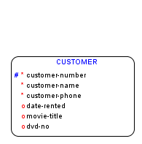

Repeats for each movie rented

3NF diagram: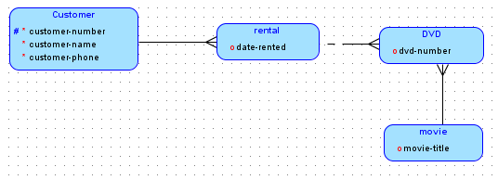

## The Entity Relationship Diagram for a college bookstore system is shown below. Assume that there is only one teacher per course and that the copies-ordered is the number of copies ordered for a particular course. The same textbook may be used in more than one course and a course may require more than one textbook.

### Indicate the normal form level for the diagram and explain why it is in that particular normal form:

This is in 1NF

### List all the functional dependencies for the data model:

Course-number > course-name

Isbn > author, title

Course-number > course-name, course-teacher

### Redraw the diagram in 3NF using Oracle Data Modeler and copy below:

**College Bookstore System**



3NF diagram:

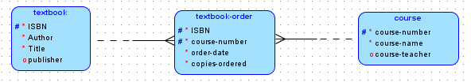

* 1. The Entity Relationship Diagram for a software inventory system is show below. Assume that each piece of software is owned by only one department.
     1. Indicate the normal form level for the diagram and explain why it is in that particular normal form :

2NF, there’s nothing repeating, but there’s some attributes that don’t relate to the software entity that are inside it.

* + 1. List all the functional dependencies for the data model:

Vendor-id > vendor-contact-name, vendor-name, vendor-phone

Software-id > software-name, version, unit-cost, number-of-copies

Department-code > department-coordinator, department-name

* + 1. Redraw the diagram in 3NF using Oracle Data Modeler and copy below:

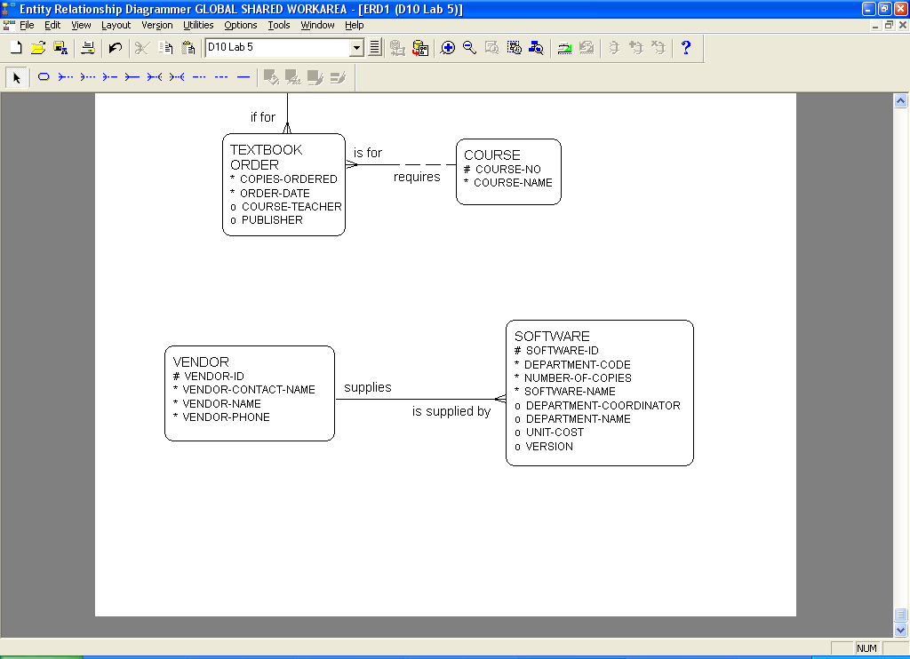

**Software Inventory System**

3NF Diagram: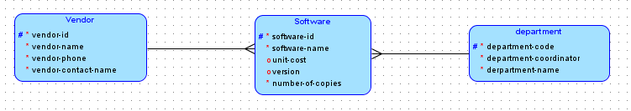

* 1. The Entity Relationship Diagram for a dental care system is shown below. Each insurance company has a code and the insured maximum and the deductible are the same for all the clients of the insurance company. Individual members of a household are provided with a dental service and the *insuree* is charged for all the charges incurred by members of his/her household. The *insuree* may or may not be a patient. The head of household is the *insuree*.
     1. Indicate the normal form level for each entity and explain why it is in that particular normal form:

0NF – The patient info repeats in the household entity, so yea. 0NF.

* + 1. List all the functional dependencies for the data model:

Household-number > head-of-household-name, household-address

Insurance-code > insurance-company-name, insurance-deductible, insured-maximum

Patient-number > patient-name, patient-birthday, relationship-to-household-head

Service-code > service-fee

* + 1. Redraw the 3NF data model using Oracle Data Modeler and copy below:

**Dental Care System**

*repeats for each member of the* *household*

3NF Diagram: